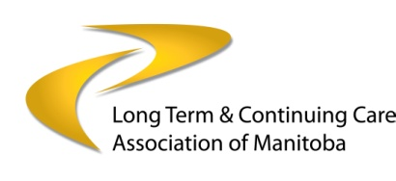

Long Term & Continuing Care Association of Manitoba

Award for Excellence Nomination Form

Deadline for submissions: February 1, 2017

The Awards Ceremony will be held at the

LTCAM Annual Provincial Conference on

May 9, 2017

A few of our past recipients

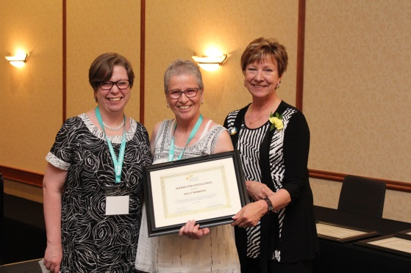
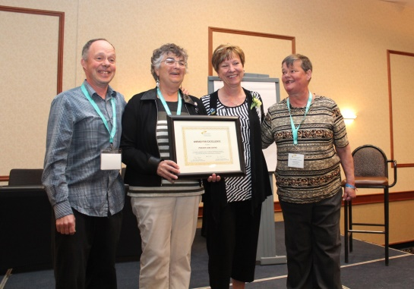

Poseidon Care Centre Holly Morrison

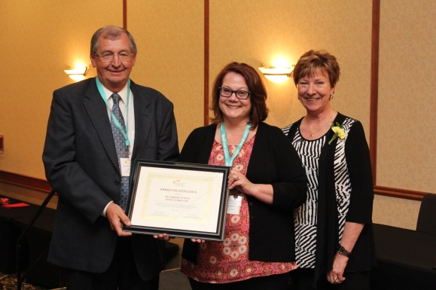
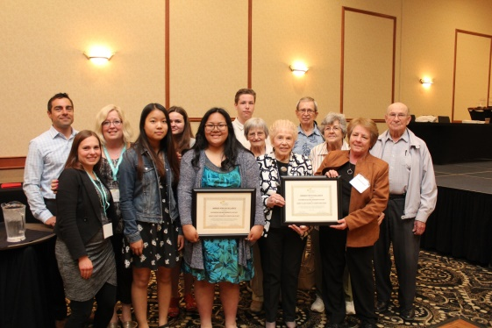

Riverwood Square Residents & Staff The Gardens on Tenth Board of Directors

& Henry G Izatt School Students & Staff

Awards for Excellence are given each year by the Long Term & Continuing Care Association of Manitoba to honour the efforts and dedication of an outstanding person, team or volunteer who has provided exceptional service to clients/residents within the long term care continuum.

Do you know someone who goes “above and beyond” and works or volunteers in for example, a Personal Care Home, Supportive Housing Residence, Retirement Residence, (sometimes known as Assisted Living), and/or a Community or Seniors Resource Centre? Now you can let this person know how much they are valued!

Judging
An independent panel of judges will review all of the nominations and select the award recipients. The award is open to all staff and volunteers in the Province of Manitoba. Membership in LTCAM is not required.

The Long Term & Continuing Care Association of Manitoba

2017 Awards for Excellence

Instructions

- Complete the attached nomination sheet in full. Only electronic submissions in Word will be accepted. No pdfs please, as your winning submission will form part of the award presentation. Please do not hesitate to send ‘lots’ of photos! But keep in mind, that we require consent for each of the persons shown in the photos.

NEW!! LTCAM is adding a new learning feature to its website in relation to these awards. We would like to publish the award nomination information on our website. We request that the Award recipient consent to having this information published on our website along with their contact information to enable those who are interested in learning more about their accomplishments.

- Tell us about your nominee and what makes this nominee unique or exceptional.
Attach a statement describing the nominee’s services and how they have affected the organization or community. Provide details on the following topics, if applicable. Please be thorough, as your description will be the only information available to the judges. Photos in jpeg format are encouraged. Should your nomination be successful, you must provide written consent from all persons in the photos as they will be shown at the conference and will be posted on our website.

2.1 Activity Briefly describe the program, service or activity for which the candidate is being nominated.

2.2 Need Describe the need filled by the nominee. Why was the need important to the community or recipient of service?

2.3 Method What did the nominee do to address the need?

2.4 Impact What was the outcome of the candidate’s efforts? How many people benefited? What was actually accomplished?

2.5 Summary What is unique or exceptional about the nominee’s contribution? How is the nominee an inspiration to others? Why should the Award be given to this nominee?

2.6 Sustainability (the capacity to endure) How sustainable is the work that this person does?

Include information that may help the judges understand the value and impact of the nominee’s activities. Highlight specific section(s) for the judges’ attention such as: innovation in type & delivery of program, benefit to those who are served, need, method and creativity, impact, and commitment.

- Email all information in Word format, electronically, on or before February 1, 2017 to: jlegeros@ltcam.mb.ca

Nominee:

Name:
Email (required):

Organization:
Position:
Address:
City/Town:
Province:
Postal Code:
Daytime Phone:
Cell phone:

Submitted By:

Name:
Email (required):

Organization:
Position:
Address:
City/Town:
Province:
Postal Code:
Daytime Phone:
Cell phone:
Relationship to nominee:
Have you advised the nominee?
References (submit two):

Thank you
Send via email - in Word format to jlegeros@ltcam.mb.ca on or before February 1, 2017

